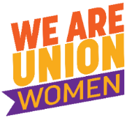
Pay Equity Fact Sheet
What is pay equity?
Sometimes called 'equal pay for work of equal value' or 'comparable worth', pay equity is the idea that men and women should be paid the same for work of equal or comparable value. In other words, women who perform work that has equal levels of skill required or responsibility involved, under the same or comparable conditions, should be paid the same as men.
In theory, women in Australia have been paid the same as men since the equal pay decisions of 1969 and 1972 in the federal Conciliation and Arbitration Commission. However, statistics show that women still earn less than men and that the gender pay gap is once again continuing to widen.
The gender pay gap
The gender pay gap is the difference between women’s and men’s earnings, expressed as a percentage of men’s earnings.
It can be calculated in a number of ways and this sometimes leads to differences in the figures cited as “the gender pay gap”.
Australia’s Workplace Gender Equality Agency (WGEA) defines the gender pay gap as:
the difference between women’s and men’s average weekly full-time equivalent earnings, expressed as a percentage of men’s earnings.
WGEA calculates the national gender pay gap using Australian Bureau of Statistics' (ABS) Full-Time Adult Average Weekly Ordinary Time Earnings (AWOTE) Trend data from the Average Weekly Earnings (AWE) survey (cat. no. 6302.0).
In 2018, WEGA calculated the national gender pay gap as 15.3% noting that this gap has hovered between 15% and 19% for the past two decades.
We know that using AWOTE means that factors such as regular overtime and additions to remuneration like discretionary or performance bonuses and other benefits such as the provision of motor vehicles as part of a package are not included. Data tells us when these other remuneration elements are included the gender pay gap widens further.

The following tables illustrates this. Taking account of Full-Time annualised total remuneration the gender pay gap currently sits at 22.4%.

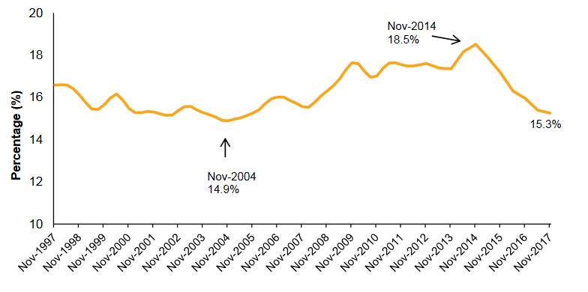
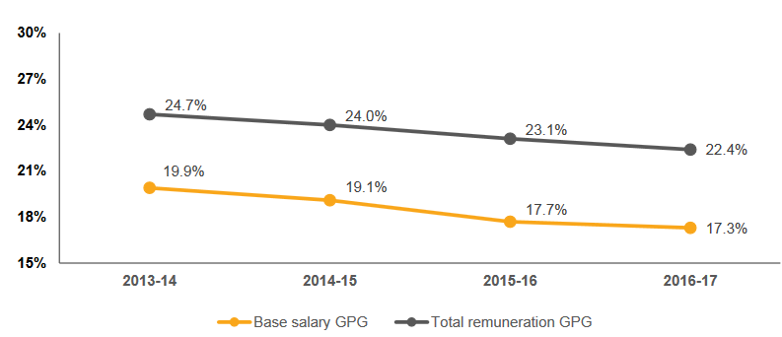

Source: WGEA Gender Pay Gap Fact Sheet

In reality there is not one gender pay gap but numerous gender pay gaps. The gap is different between the public and private sectors; in different industries; for ongoing and casual workers; and is in fact likely to be different based on ethnicity (however little data is gathered on this basis).
However, what remains constant is the fact that for every woman the gender pay gap is in double digits.
Why the gap?
The gap between women's and men's earnings occurs for a number of interrelated reasons:
The undervaluation of women's skills - This is due to a range of social historical and industrial factors. Long held prejudices about women and the nature of their skills have prevented any objective assessment of women's work. The most obvious example happens where women's skills are viewed as 'natural attributes' rather than workplace skills. For example, skills related to caring and nurturing, and communication.
Women's lower share of discretionary payments: - Women workers continue to receive significantly lower levels of discretionary payments compared to men. These include such things as over award payments, bonuses, service increments, commissions and profit sharing payments. To make matters worse, women tend to be concentrated in jobs and industries where there is no access to these kind of payments
Occupational and industrial segregation - Women workers tend to be concentrated in particular occupations and industries because of societal expectations about what is suitable work for women and in some cases, historical restrictions on what work women are legally allowed to perform. For example, women are concentrated in occupations such as teaching, nursing, and childcare work.
Access to education and training - In many cases women's work skills are not formally recognised and are developed outside of formal education and training systems.
The impact of family responsibilities - Working women usually carry a greater share of the responsibility for caring for other family members and performing unpaid work in the home than their male counterparts. This may affect their earnings because they:
- May not be able to work full time, take on extra responsibilities, access training and career development opportunities, or work in jobs where flexible working arrangements are not available;
- May have broken employment patterns due to career breaks to care for children or other family members which are likely to have a negative impact on career progression;
- May be subject to employers' negative perceptions about the effect of family responsibilities on work performance, attitude and loyalty to the organisation which in turn may affect pay and promotional prospects.
Women's concentration in part time and casual employment - While the availability of part time work is important for many women (and men) with family responsibilities, women's concentration in part time and casual employment has implications for pay equity. These include:
- Lower levels of access to training and more limited opportunities for advancement and career development than full time workers. This may be partly due to many employers believing that part time and casual employees are not committed to their jobs;
- Lower levels of unionisation and participation in unions than full time employees (Part-time, casual and women workers are benefiting most from union membership, earning up to 43% more than their non-union colleagues, according to Australian income figures released in 2002)
- In the case of casual employment, women have no permanency and few employment benefits.
Deregulation of the labour market - In Australia the centralised wage fixing system had for many years been credited with our relatively good performance in closing the gender age gap, compared to countries with more decentralised systems. Since the Howard Government's attacks on the Australian unions in the early 1990s and the widespread introduction of enterprise bargaining and individual contracts, the gender wage gap in Australia has widened. This is due to a combination of factors such as women having less bargaining power due to less labour force experience, lower representation in full-time employment and the trade union movement.
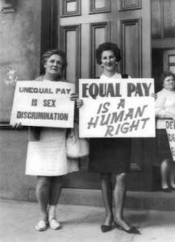
Women outside Trades Hall in Melbourne 1969
Pay Equity Timeline

1912
- Women’s minimum wage set at 54% of men’s wages

1950
- Women’s minimum wage set at 75% of men’s wages
1951
- The International Labour Organization of the United Nations adopted its equal pay convention. It recommended “equal remuneration for men and women workers for work of equal value with a view to providing a classification of jobs without regard to sex.

1972
- ACTU test case establishes principle of ‘equal pay for work of equal value’
1986
- Affirmative Action Act (Equal Employment Opportunity for Women) introduced

1999
- Equal Opportunity for Women in the Workplace Act (EEOWA) introduced

2008/9

The Queensland Services Union lodged and application for a new award for Social and Community Services Workers which included 2009 a claim to increase pay rates for workers covered by the new Award, to correct historical undervaluation, as well as an Equal Remuneration Component to maintain ongoing wage parity because of a lack of enterprise bargaining in the sector. The decision QIRC awarded pay increases (of between 19 & 44%) to address the historical undervaluation of work, concluding gender undervaluation was at the core of the work value that had been applied to this work. This decision underpinned the successful ASU national pay equity case in 2012.

2009
- Australia’s first Paid Parental Leave scheme
- Review of EEOWA and Sex Discrimination Act
- Pay Equity Inquiry launched
- Fair Work Act defines equal pay more broadly as ‘equal remuneration for work of equal or comparable value’
- BPW Australia and ACTU form Equal Pay Alliance to address the pay gap and invite businesses, unions, community groups and women’s organisations to join.

2011
- ASX Corporate Governance Gender Diversity Principles and Recommendations introduced.

2012
- Australian Services Union wins national Social and Community Services Pay Equity Case, properly valuing community work in the social and disability sectors.
- Dad and Partner Pay Scheme introduced
- Workplace Gender Equality Act introduced

2013
- Australian Council of Trade Unions launches the ‘Time To Care’ Campaign to improve work and family balance options for employees
- Government provides funding to childcare sector to help increase wages for early childhood education and care workers
- United Voice launches equal pay case for childcare workers
- Low paid care workers in residential nursing homes in New Zealand launch a test case under the Equal Pay Act (1972) via their union the SFWU. The NZ Employment Court rules in the first instance that this claim can be made. This reinvigorates the Equal Pay campaign in New Zealand.

2014
- The Workplace Gender Equality Agency expanded their national survey of employers to include remuneration data for the first time
- G20 countries met in Sydney to discuss global trade and finance, bringing business leaders together at an important event highlighting the difference women’s empowerment and gender equity make to the bottom line
- The Grattan Institute reported that a six per cent rise in female participation would increase the size of the Australia economy by around $25 billion a year
- The Gender Pay Gap rose to 18.2%, which was the highest since the comparison between women's and men's average earnings were first produced in the early 1990's
2015
- It was estimated that family violence cost the Australian economy $22 billion each year.
- Victoria’s Andrews Government launched the Royal Commission into Family Violence
2016
- The Royal Commission into Family Violence Report was handed down, including recommendations for Family Violence Leave
2017
- The Fair Work Commission rejects the ACTU bid to make family violence leave a minimum standard
- Penalty Rates were cut by the FWC, with women workers being mostly affected by the decision
Other Resources
www.wgea.gov.au/sites/default/files/Gender_Pay_Gap_Factsheet.pdf
www.equalpayday.com.au
www.security4women.org.

